**CREATE A PRIVATE BUCKET IN AWS.UPLOAD A FILE AND CHECK BY PRESIGNED URL THAT YOU CAN ACCESS THE FILE OR NOT.**

**Visit** **aws.amazon.com** **and Sign in.Click on the search field and type “s3” in the search field and select S3**

**Click on “Buckets”**

**1.….**.

**2.**

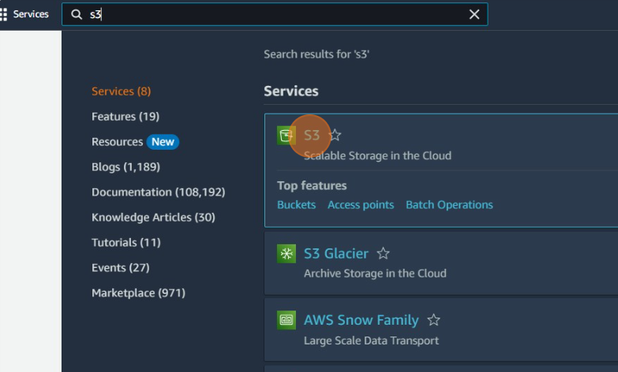

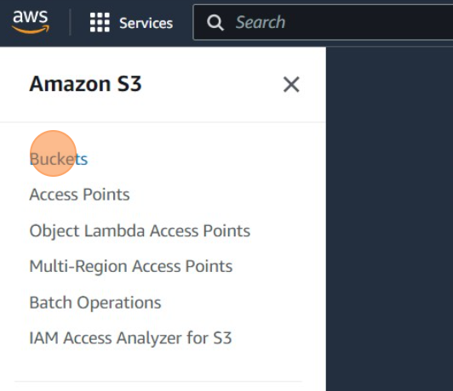

**Click the "Bucket name" field and type "hiteshpvtbucket" and keep all other options unchanged.**

**Click on “Create Bucket”**

**s**

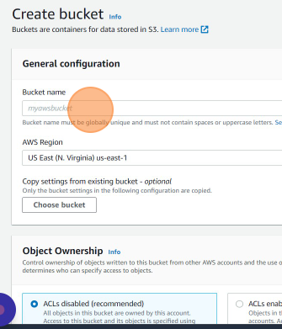

**3.**

**4.….**.

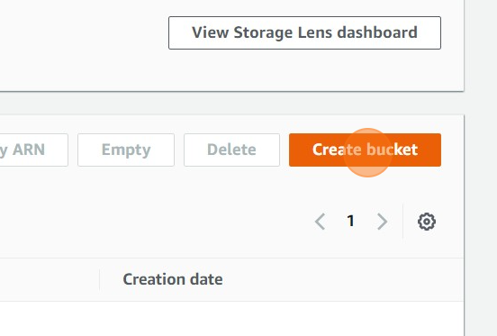

**Click on “Create bucket”**

**Click on “hiteshpvtbucket”**

**5.….**.

**6.**

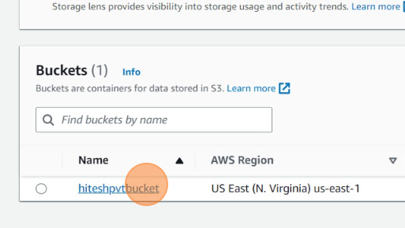

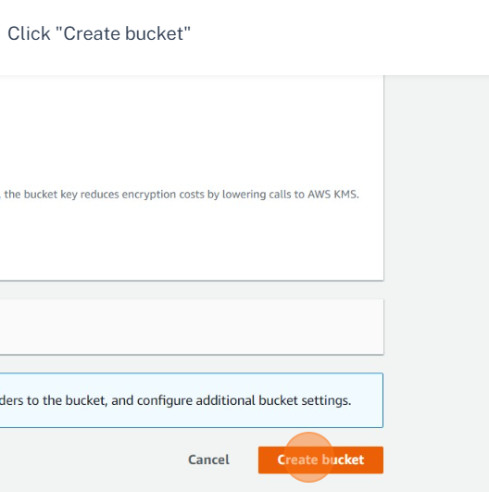

**Add files and folders which you want to upload and click upload**

**Click on “Upload”**

**s**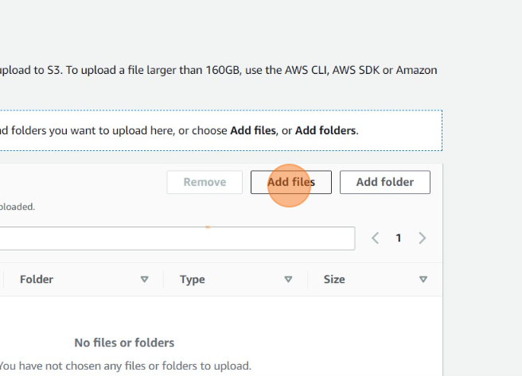

**7.**

**8.….**.

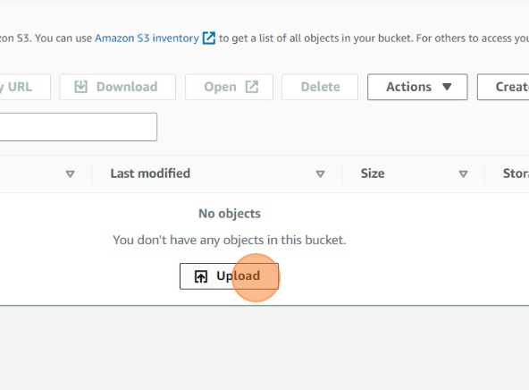

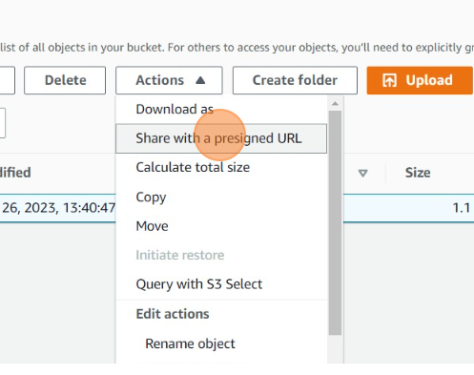

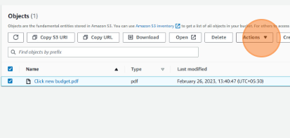

**Select the file for which you want to generate presigned url and click “Action”**

**Click on “Share with a presigned URL”**

**10.**

**9.….**.

**s**

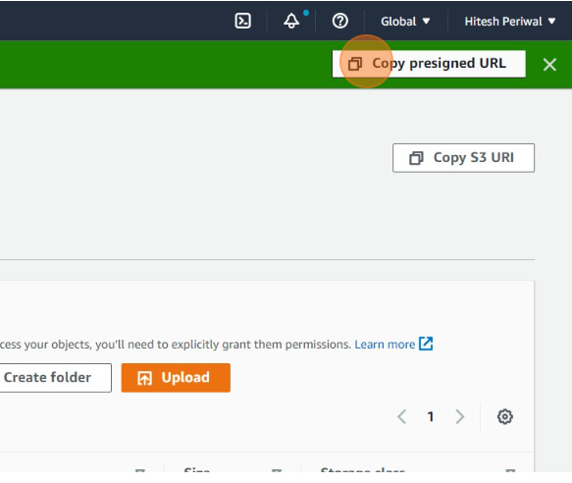

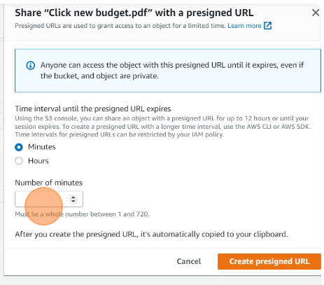

**Set the time interval until which the presigned URL expires and click on “Create presigned URL”**

**Click on “Copy presigned URL” and you will be able to access the file using the URL for the set time period only.**

**12.**

**11.**